Madagascar

## Political Stability Estimate Data

The data set shows the political stability estimate of the country each year.

## # A tibble: 19 x 5  
## country iso3c date stability stabilityCategory4   
## <chr> <chr> <dbl> <dbl> <chr>   
## 1 Madagascar MDG 1996 0.217 moderately stable   
## 2 Madagascar MDG 1998 0.197 moderately stable   
## 3 Madagascar MDG 2000 0.161 moderately stable   
## 4 Madagascar MDG 2002 -0.230 moderately unstable  
## 5 Madagascar MDG 2003 0.622 moderately stable   
## 6 Madagascar MDG 2004 0.244 moderately stable   
## 7 Madagascar MDG 2005 -0.0215 moderately unstable  
## 8 Madagascar MDG 2006 0.183 moderately stable   
## 9 Madagascar MDG 2007 0.0897 moderately stable   
## 10 Madagascar MDG 2008 -0.470 moderately unstable  
## 11 Madagascar MDG 2009 -0.733 moderately unstable  
## 12 Madagascar MDG 2010 -0.978 moderately unstable  
## 13 Madagascar MDG 2011 -0.706 moderately unstable  
## 14 Madagascar MDG 2012 -0.536 moderately unstable  
## 15 Madagascar MDG 2013 -0.660 moderately unstable  
## 16 Madagascar MDG 2014 -0.557 moderately unstable  
## 17 Madagascar MDG 2015 -0.427 moderately unstable  
## 18 Madagascar MDG 2016 -0.290 moderately unstable  
## 19 Madagascar MDG 2017 -0.334 moderately unstable

## Political Stability Estimate Plot

The plot shows the trends of stabilization and destabilization for the each country.

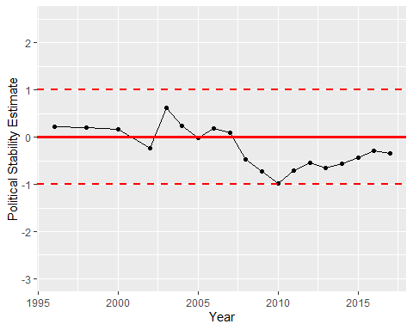

Political Stability Trend